Early ICU Deterioration Prediction using Multimodal Time-Series Data

Goal
Build a PoC that mimics real-world ICU monitoring by analyzing patient data over time. The system will use time-series vitals, labs, urine output, oxygen requirement, vasopressor usage, and timestamped doctor/nurse notes to predict whether a patient is likely to deteriorate in the next 6–12 hours.
Unlike a simple snapshot classifier, this PoC will focus on patient trajectory. The same current lab value may mean different things depending on whether it is rising or falling. Therefore, participants will engineer temporal features such as rolling averages, deltas, slopes, minimum/maximum values, and intervention escalation indicators.
The AI assistant will output a deterioration risk score, trajectory label, priority level, and top clinical drivers. For example, it may flag a patient as high risk because lactate is rising, MAP is falling, urine output is decreasing, oxygen requirement is increasing, and nursing notes mention increased work of breathing.
The final solution should include a simple ICU dashboard that ranks patients by risk and shows why each patient was flagged. The system should be positioned as clinical decision support, not autonomous diagnosis. Its purpose is to help ICU staff recognize worsening trajectories earlier, improve handover quality, and prioritize attention in a busy ICU environment.

Business Usecase
ICU patients generate continuous streams of data. Clinicians do not judge patients only by one latest value; they look at trajectory. A patient with high lactate may be improving if lactate is falling. Another patient with the same lactate may be worsening if lactate is rising. Similarly, falling MAP, rising oxygen need, increasing vasopressor dose, worsening creatinine, and poor urine output over time may indicate early deterioration.
The goal of this PoC is to build an AI system that analyzes ICU time-series data and clinical notes to predict whether a patient is likely to deteriorate in the next 6–12 hours.
The AI Bot will look at patient data over time and predict:
- Current trajectory
  - Improving
  - Stable
  - Worsening
- Near-term risk
  - Risk of deterioration in next 6 hours
  - Risk of escalation in next 12 hours
- Reason for risk
  - “Lactate rising”
  - “MAP trending downward”
  - “Oxygen requirement increasing”
  - “Urine output falling”
  - “Nurse note mentions increased work of breathing”
  - “Vasopressor dose increased”

It is not just classifying, but also interpreting

Why time-series matters in ICU
A single value may not be dangerous by itself.
For example:

Biomarker | Patient A | Patient B
Lactate now | 3.2 | 3.2

At a single point, both look similar.
But with time-series:

Time | Patient A Lactate | Patient B Lactate
8 AM | 5.1 | 1.6
12 PM | 4.2 | 2.1
4 PM | 3.2 | 3.2

With timesries/trend:
Patient A is improving.
Patient B is worsening.
Same current value, opposite clinical meaning.

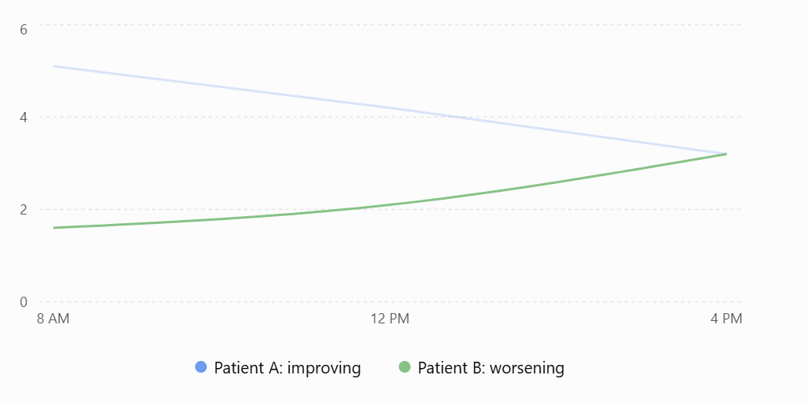

Representative/Sample Input Data

Time-series structured data
Data type | Examples
Vitals | HR, BP, MAP, RR, SpO₂, temperature
Labs | lactate, WBC, creatinine, platelets, bilirubin, pH
Outputs | urine output, fluid balance
Respiratory | oxygen flow, FiO₂, ventilator settings
Interventions | vasopressor dose, antibiotics, fluids, ventilation
Scores | SOFA-like or NEWS-like derived features

Time-linked unstructured data
Note type | Examples
Nurse note | “Patient more drowsy, increased work of breathing.”
Doctor note | “Suspected septic shock, monitor lactate.”
Handover note | “Urine output poor overnight.”
Respiratory therapist note | “Oxygen requirement increased from 4L to 10L.”

TASKS FOR PARTICIPANTS

- Create time-windowed patient data
Hint:
Instead of one row per patient, create one row per patient per time window.
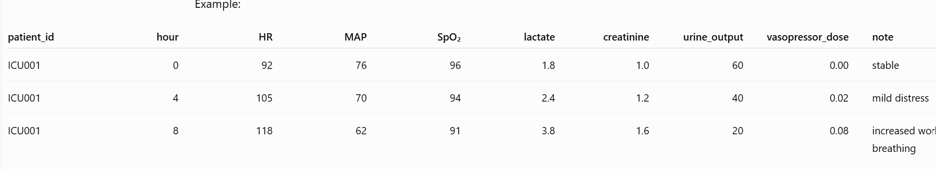
- Engineer time-series features
This is the missing core piece.
The model should not only know:
“Lactate is 3.2.”
It should know:
“Lactate increased from 1.6 to 3.2 over 8 hours.”
Feature type | Example
Latest value | current lactate, current MAP
Change from previous window | lactate delta, MAP delta
Rate of change | lactate increase per hour
Rolling average | average MAP last 6 hours
Rolling minimum/maximum | lowest SpO₂ last 6 hours
Trend slope | creatinine slope over 12 hours
Volatility | BP variability
Intervention escalation | vasopressor dose increased?
Combined signals | rising lactate + falling MAP + low urine output

- Include temporal notes
Clinical notes should also be time-stamped.
Example:
Patient ID | Time | Note
ICU001 | 8 AM | Patient alert, vitals stable.
ICU001 | 12 PM | Mild tachypnea, oxygen increased.
ICU001 | 4 PM | Patient drowsy, increased work of breathing, urine output poor.
Use NLP or LLM extraction to convert notes into temporal signals:
{
“patient_id” : “ICU001”,
"time": "4 PM",
"respiratory_distress": true,
"mental_status_worsening": true,
"low_urine_output": true,
"overall_note_signal": "worsening"
}
Then combine these with structured trends.

Modeling
Investigate different modelling techniques to solve the above problem
Pointers:
Level 1 – Simple - Tabular time-window model
Convert time-series into engineered features.
Use:
- Logistic Regression
- Random Forest
- XGBoost / LightGBM
This is easiest and most classroom-friendly.
Level 2: Sequence model
Input:
latest_lactate
lactate_delta_6h
map_delta_6h
spo2_min_6h
urine_output_avg_6h
vasopressor_dose_delta
note_worsening_signal
Output:
risk of deterioration in next 6 hours
Use the raw sequence instead of manually engineered trends.
Models:
- LSTM
- GRU
- Temporal CNN
- Transformer encoder for time-series
Input shape:
patient × time_steps × features
Example:
ICU001 × last 12 hours × [HR, MAP, SpO₂, lactate, creatinine, urine_output, vasopressor_dose]
Output:
deterioration risk in next 6 hours

Level 3: Multimodal model
Combine:
- Time-series model for vitals/labs
- NLP model for notes
- Explanation layer
Architecture:
Vitals/labs over time → Time-series model ┐
├→ Risk score + trend + explanation
Clinical notes over time → NLP/LLM signals ┘

DASHBOARD
A dashboard that should show something like below:
Patient | Risk | Trend | Priority | Why
ICU-007 | 87% | Worsening | Urgent | Lactate ↑, MAP ↓, vasopressor ↑
ICU-014 | 61% | Watch | Medium | Fever, WBC ↑, oxygen need ↑
ICU-021 | 24% | Improving | Routine | Lactate ↓, BP stable
A streamlit UI maybe built for the above (Optional)

Evaluation
Evaluate the model using test data.
Compare models

